CSE3002 – Internet and web programming

JavaScript Arrays Practice

Pinni Venkata Abhiram

20BAI1132

Question – 1

Teacher has CAT1marks of iwp in two arrays named as iwp1 and iwp2.Develop a code to put marks from these two arrays into a single array named as iwp_cat1for easy processing.

HTML Code

<!DOCTYPE html>

<html lang="en">

<head>

    <meta charset="UTF-8">

    <meta http-equiv="X-UA-Compatible" content="IE=edge">

    <meta name="viewport" content="width=device-width, initial-scale=1.0">

    <title>Arrays 1</title>

</head>

<body style="margin: 30px; border: 2px solid;">

    <h1 style="font-size: 40px; padding-left: 30px;">Using concat</h1>

    <p style="padding: 20px;" class="filter2"></p>

    <h1 style="font-size: 40px; padding-left: 30px;">Without using concat</h1>

    <p style="padding: 20px; padding-top: 40px;" class="filter3"></p>

    <script src="array1.js"></script>

</body>

</html>

JS Code

const iwp1 = [20,23,24,21,22,18,15,16,19,18,17]

const iwp2 = [10,12,14,13,8,5,6,7]

//Using the concat method for concatenation

var iwp_cat1 = [];

iwp_cat1 = iwp1.concat(iwp2);

document.querySelector('.filter2').innerHTML = "Elements of array1 are : " + iwp1 + "<br>" + "Elements of array2 are : " + iwp2 + "<br>" + "Elements after concat are : " + iwp_cat1;

document.querySelector('.filter2').style.fontSize = "200%";

//Using the normal iterative method for concatenation of 2 arrays

var iwp_cat1_new = [];

for (var i = 0 ; i < iwp1.length ;i++)

{

    iwp_cat1_new.push(iwp1[i]);

}

for (var i = 0 ; i < iwp2.length ; i++)

{

    iwp_cat1_new.push(iwp2[i]);

}

document.querySelector('.filter3').innerHTML = "Elements of array1 are : " + iwp1 + "<br>" + "Elements of array2 are : " + iwp2 + "<br>" + "Elements after concat are : " + iwp_cat1_new;

document.querySelector('.filter3').style.fontSize = "200%";

Output

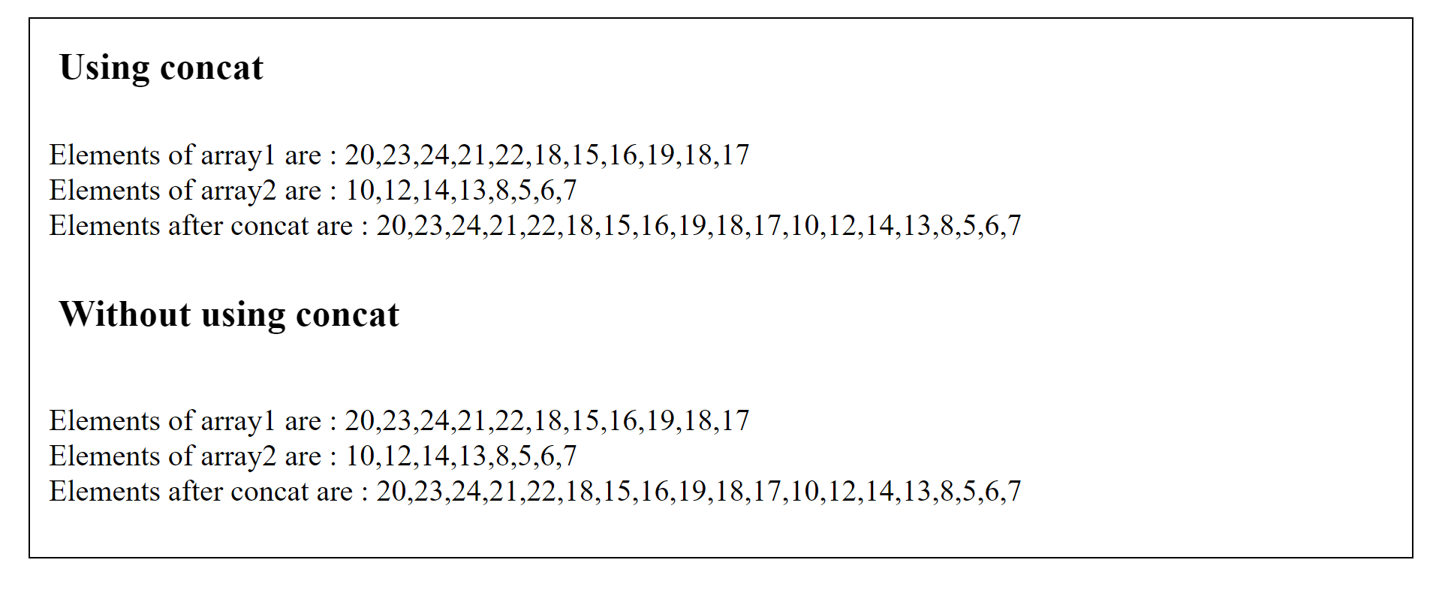

Question – 2

Teacher has students’names those who have joined iwp class on 4-1-2022in an array named as A. On 6thJan 2022, some students have joined the class and she has those names in an array named as B. Now she would like to add the names from B array toA array at the end. Write the appropriate code to do the same.

HTML Code

<!DOCTYPE html>

<html lang="en">

<head>

    <meta charset="UTF-8">

    <meta http-equiv="X-UA-Compatible" content="IE=edge">

    <meta name="viewport" content="width=device-width, initial-scale=1.0">

    <title>Arrays 1</title>

</head>

<body style="margin: 30px; border: 2px solid;">

    <h1 style="font-size: 40px; padding-left: 30px;">Using concat</h1>

    <p style="padding: 20px;" class="filter3"></p>

    <h1 style="font-size: 40px; padding-left: 30px;">Without using concat</h1>

    <p style="padding: 20px; padding-top: 40px;" class="filter4"></p>

    <script src="array2.js"></script>

</body>

</html>

JS Code

const a = ["Abhi","Meghna","Indra"];

const b = ["Aron","Adhi","Rohit"];

// Using the process of concatenation

var arr3 = [];

arr3 = a.concat(b)

document.querySelector('.filter3').innerHTML = "Elements of array A are : " + a + "<br>" + "Elements of array B are : " + b + "<br>" + "Elements after concat are : " + arr3;

document.querySelector('.filter3').style.fontSize = "200%";

//Without using the process of concatenation

var arr4 = [];

for (var i = 0 ; i < a.length ;i++)

{

    arr4.push(a[i]);

}

for (var i = 0 ; i < b.length ; i++)

{

    arr4.push(b[i]);

}

document.querySelector('.filter4').innerHTML = "Elements of array A are : " + a + "<br>" + "Elements of array B are : " + b + "<br>" + "Elements after concat are : " + arr4;

document.querySelector('.filter4').style.fontSize = "200%";

Output

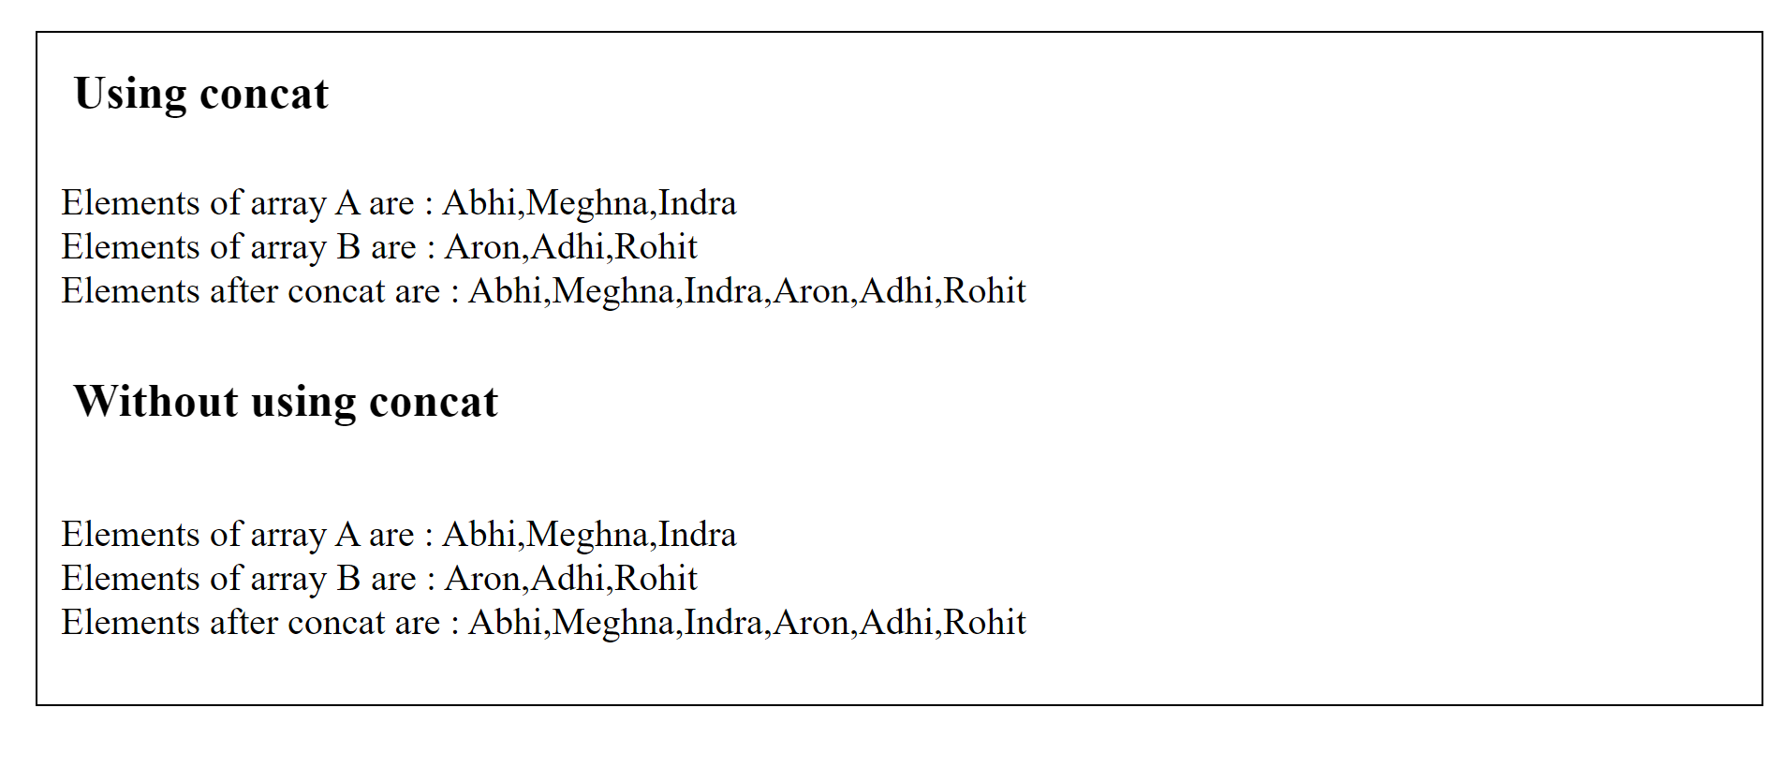

Question – 3

Develop a suitable code which performs all the below array operations with (i)numerical and (ii) string array objects.

Insertions, deletions at any positions, sorting in ascending and descending order.

HTML Code

<!DOCTYPE html>

<html lang="en">

<head>

    <meta charset="UTF-8">

    <meta http-equiv="X-UA-Compatible" content="IE=edge">

    <meta name="viewport" content="width=device-width, initial-scale=1.0">

    <title>Arrays 1</title>

</head>

<body style="margin: 30px; border: 2px solid;">

    <h1 style="font-size: 40px; padding-left: 30px;">Insertion</h1>

    <div class="arr" style="padding-left: 30px; font-size: 25px;"></div><br>

    <form style="font-size: 20px; padding-left: 35px;" name="f1">

        Enter input to be added in the array :

        <input type="text" name="t1"> <br>

        Enter the place to be inserted :

        <input type="text" name="t2"><br><br>

        <input type="button" onclick="function1()" value="Submit your value">

    </form>

    <br>

    <div class="c1" style="padding-left: 35px; font-size: 25px;"></div><br><br>

    <h1 style="font-size: 40px; padding-left: 30px;">Deletion</h1>

    <form style="font-size: 20px; padding-left: 35px;" name="f2">

        Enter the place to be deleted :

        <input type="text" name="t3"><br><br>

        <input type="button" onclick="function2()" value="Submit your value">

    </form>

    <br><br>

    <div class="c2" style="padding-left: 35px; font-size: 25px;"></div><br>

    <hr style="padding-bottom: 30px;">

    <div class="c3" style="padding-left: 35px; font-size: 25px;"></div><br>

    <div class="c4" style="padding-left: 35px; font-size: 25px;"></div><br>

    <hr>

    <h1 style="font-size: 40px; padding-left: 30px;">Insertion for strings</h1>

    <div class="arr2" style="padding-left: 30px; font-size: 25px;"></div><br>

    <div class="arr" style="padding-left: 30px; font-size: 25px;"></div><br>

    <form style="font-size: 20px; padding-left: 35px;" name="f3">

        Enter input to be added in the array of strings :

        <input type="text" name="t4"> <br>

        Enter the place to be inserted :

        <input type="text" name="t5"><br><br>

        <input type="button" onclick="function3()" value="Submit your value">

    </form>

    <br>

    <div class="c5" style="padding-left: 35px; font-size: 25px;"></div><br><br>

    <h1 style="font-size: 40px; padding-left: 30px;">Deletion for strings</h1>

    <form style="font-size: 20px; padding-left: 35px;" name="f4">

        Enter the place to be deleted :

        <input type="text" name="t6"><br><br>

        <input type="button" onclick="function4()" value="Submit your value">

    </form>

    <br><br>

    <div class="c6" style="padding-left: 35px; font-size: 25px;"></div><br>

    <hr style="padding-bottom: 20px;">

    <div class="c7" style="padding-left: 35px; font-size: 25px;"></div><br>

    <div class="c8" style="padding-left: 35px; font-size: 25px;"></div><br>

    <script src="array3.js"></script>

</body>

</html>

JS Code

var arr1 = [2,3,4,5,6,20,7,8,9,10]

document.querySelector('.arr').innerHTML = "Original Number array is : " + arr1;

function function1()

{

    var arr4 = [];

    const input = parseInt(document.f1.t1.value);

    const input2 = parseInt(document.f1.t2.value);

    for (var i = 0 ; i < input2 - 1 ; i++)

    {

        arr4.push(arr1[i]);

    }

    arr4.push(input)

    for (var i = input2 - 1 ; i < arr1.length ; i++)

    {

        arr4.push(arr1[i]);

    }

    document.querySelector('.c1').innerHTML = "After insertion at given value the array is : " + arr4;

}

function function2()

{

    const input = parseInt(document.f2.t3.value);

    for( var i = 0; i < arr1.length; i++){

        if ( i === input - 1) {

            arr1.splice(i, 1);

        }

    }

    document.querySelector('.c2').innerHTML = "After deletion at given value the array is : " + arr1;

}

document.querySelector('.c3').innerHTML = "Sorting the elements in ascending order : " + arr1.sort(function(a, b) {

    return a - b;

  });

document.querySelector('.c4').innerHTML = "Sorting the elements in descending order : " + arr1.sort(function(a, b) {

  return b - a;

});

var string1 = ["Abhi","Aron","Rohit","Arjun","Smith","Jacob"];

document.querySelector('.arr2').innerHTML = "Original string array is : " + string1;

function function3()

{

    var arr6 = [];

    const input = document.f3.t4.value;

    const input2 = parseInt(document.f3.t5.value);

    for (var i = 0 ; i < input2 - 1 ; i++)

    {

        arr6.push(string1[i]);

    }

    arr6.push(input)

    for (var i = input2 - 1 ; i < string1.length ; i++)

    {

        arr6.push(string1[i]);

    }

    document.querySelector('.c5').innerHTML = "After insertion at given value the array is : " + arr6;

}

var string2 = [];

for (var i of string1) {

    string2.push(i);

}

function function4()

{

    const input = parseInt(document.f4.t6.value);

    for( var i = 0; i < string1.length; i++){

        if ( i === input - 1) {

            string1.splice(i, 1);

        }

    }

    document.querySelector('.c6').innerHTML = "After deletion at given value the array is : " + string1;

}

document.querySelector('.c7').innerHTML = "Sorting the elements in ascending order : " + string2.sort();

document.querySelector('.c8').innerHTML = "Sorting the elements in descending order : " + string2.reverse();

Output

For Numerical Array Values

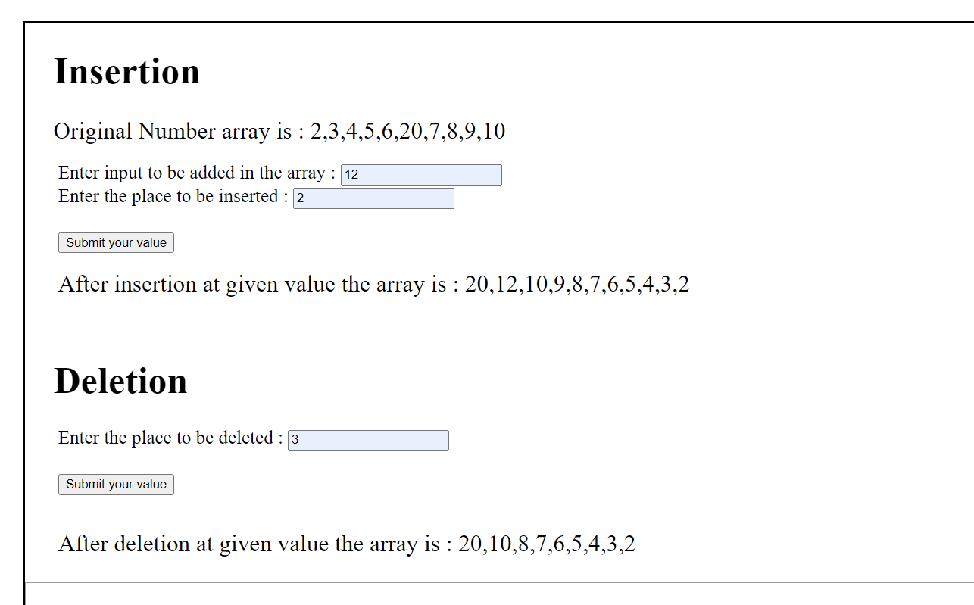

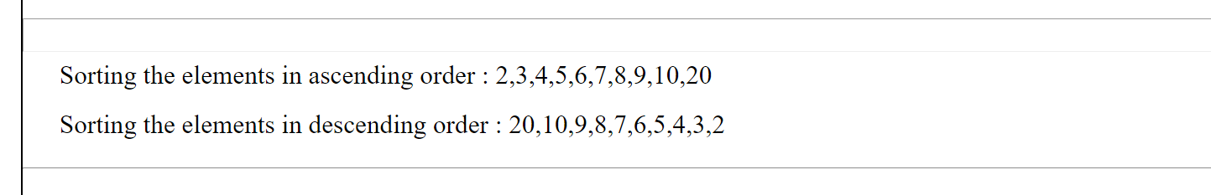

For String Array Values

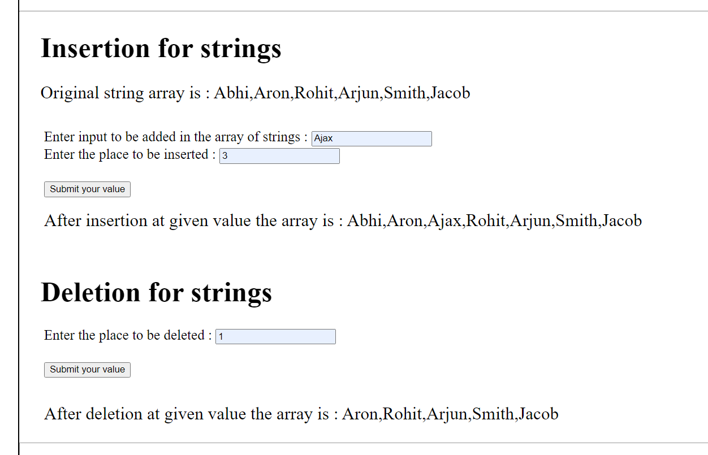

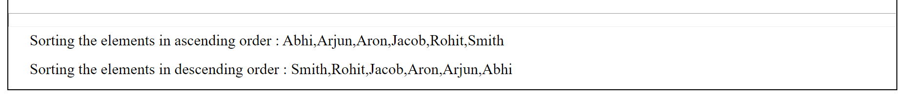

Thank you ma’am

Pinni Venkata Abhiram

20BAI1132